TP02 - The Big Mac Index

Team 0X

DS510 Artificial Intelligence for Data Science

Master of Computer Science (MSCS) Program, School of Technology and Computing, City University of Seattle

Tyler Kepler: [keplertyler@cityuniversity.edu](mailto:keplertyler@cityuniversity.edu)

Katelyn Ashworth: [ashworthkatelyn@cityuniversity.edu](mailto:ashworthkatelyn@cityuniversity.edu)

Nikolaj Wochnik: [wochniknikolaj@cityuniversity.edu](mailto:wochniknikolaj@cityuniversity.edu)

Jeff Nelson:[nelsonjeff@cityuniversity.edu](mailto:nelsonjeff@cityuniversity.edu)

**Abstract**

This project aims to explore and model global purchasing power parity (PPP) using the Big Mac Index, a lighthearted yet insightful economic indicator published by *The Economist*. The index compares the prices of McDonald's Big Macs in different countries to estimate the relative value of currencies and assess whether they are overvalued or undervalued. Leveraging the 2024 Big Mac Index dataset from Kaggle, our project investigates the relationship between burger prices, exchange rates, and key economic indicators across various countries and time periods. We will apply supervised learning algorithms such as linear regression, decision trees, and ensemble methods to predict currency valuation and identify underlying patterns influencing local pricing. The results will be evaluated based on model accuracy and economic interpretability. This project not only demonstrates the applicability of machine learning to real-world economic data but also highlights the strengths and limitations of algorithmic insights in global financial contexts.

**Keywords:** AI, Big Mac, Algorithm, regression, supervised learning, currency, machine learning, finance, Purchasing Power Parity

1. **Introduction**

Purchasing Power Parity (PPP) is a key principle in economics and provides a useful framework for comparing the relative value of currencies across nations by assessing the cost of a standardized good. The Economist’s “Big Mac Index” offers a fun yet recognized measure of PPP by examining the price of a McDonald’s Big Mac in different countries. In this project, a sample of nations were analyzed using the Big Mac Index dataset from Kaggle to explore currency valuation and price disparities.

To conduct this analysis, the supervised learning techniques—specifically Decision Trees and Linear Regression were used to model and interpret PPP patterns. The dataset was prepared using standard preprocessing methods, and the resulting models are evaluated in terms of accuracy, interpretability, and practical insights. Finally, the results are discussed with attention to both the advantages and limitations of each approach, along with suggestions for potential extensions in future work.

1. **Literature Review**

Purchasing Power Parity (PPP) is a recognized tool in international economics to measure and evaluate the relative value of currencies by comparing the cost of a good common to all countries being evaluated. In the case of this project the cost of the Big Mac from McDonalds is being used for comparison. The use of the Big Mac index has been criticized for being too simplistic in terms of more complex economic factors, but it remains a viable tool for analysis. The Economist Magazine introduced the index in 1986 with the expectation that it could help determine if currencies were undervalued or overvalued. The Index can be used to potential currency misalignments. Modern machine learning methods such as linear regression, decision trees, and ensemble methods have proven valuable tools in PPP analysis. These techniques have been helpful in economic analysis but one must be careful that the interpretation of results is accurate and the algorithmic results are as intended. This project contributes to the literature by showing a specific use case of PPP evaluation using the Big Mac Index with a dataset from a recognized source (Kaggle) and using state of the art supervised learning tools.

1. **Dataset**

The dataset chosen for the project is the “Big Mac Index 2000-2024" found on the Kaggle website at: [Big Mac Index 2000-24.](https://www.kaggle.com/datasets/justine231/big-mac-index-2024) The dataset was revised by converting each sheet into a .csv file and concatenating them into a single file. Further refinements included adjusting all column names to be lowercase with spaces shown as an underscore. Unnecessary columns were also removed so the result are columns showing *country name, iso_a3 code, currency code, local_price, dollar_ex, dollar_price, and year of the data* which were deemed as necessary columns for the purpose of analyzing the difference between Big Mac prices*.* Duplicates were removed from specific columns such as “Year”. This is necessary so there aren’t multiple counts of a specific country’s Big Mac price. Additional clean up in python coding in the notebook included converting currency data types to floats, dropping duplicate columns, dropping rows with missing data, and saving the refined data to a new file to be used in the modeling stage. Converting the data to a specific type, allows the model to consider all data the same. Dropping duplicates and missing data ensures that there is only one row for each country which is necessary to ensure that results are per country as needed for this project.

**4.1 Modeling - Decision Tree**

The supervised learning models of Decision Trees and Linear Regression were chosen for the project as they both are strong tools for such an analysis as PPP and both have unique characteristics that provide clear and useful results. The combination of the two models shows a balanced approach.

The Decision Tree model is well suited due to its ability to capture non-linear relationships in the data such as the economic indicators found in the data set. The model is also flexible, and the results are straightforward and interpretable, and the model provided helpful in determining undervaluing or overvaluing of the currencies analyzed.

Linear Regression is also a good tool for the PPP analysis of the Big Mac Index as it provides a good baseline by quantifying relationships between prices, exchange rates, and time. This is helpful in overall economic analysis.

**4.2 Analysis - Decision Tree**

The Decision Tree analysis indicates an overemphasis on undervalued currencies as indicated by the Decision Tree and the Classification Report. This is seen by a higher recall for category “0”. The planned remedy for this shortcoming will be to rebalance the weighting of the classes to mitigate the skew towards undervalued currencies.

**4.3 Results – Decision Tree**

The classification report below shows the results of the model in terms of signifying undervalued or overvalued currencies.

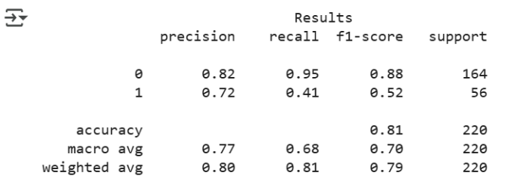

“0” indicates undervalued and “1” indicates overvalued currencies. These results indicated the model is good at recognizing undervalued currencies (95%) but poor at identifying overvalued currencies (41%). This indicates a need for rebalancing the model. In practical terms in relation to PPP, this means that if a Big Mac is cheaper than in the U.S. (after converting with exchange rates), the currency is undervalued; if it is more expensive, the currency is overvalued.

The results of Feature Importance calculation are listed below:

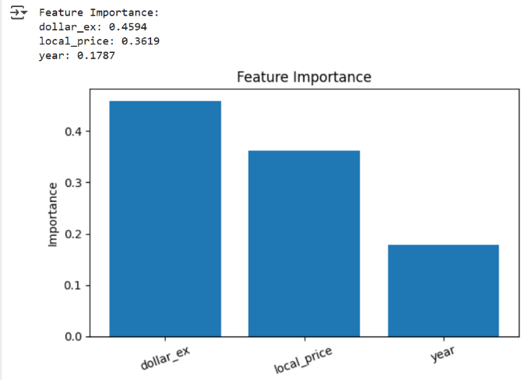

From these results we see the model put the highest importance on the dollar exchange rate, followed by local price, and lastly by year. This makes sense as PPP does rely on exchange rate adjustments. The local price of the Big Mac is also important as this is the good being compared to US pricing. The year is less important as it is the pricing comparisons that matter the most in the PPP analysis.

The Decision Tree results are below:

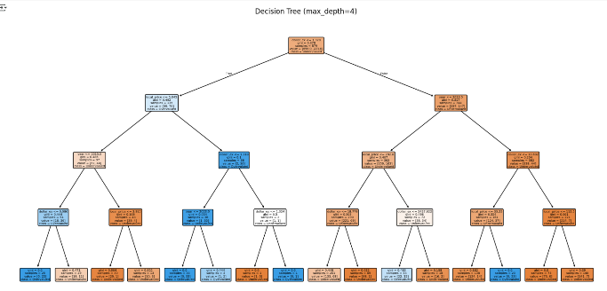

The Decision Tree provides a visual representation of the results of the model. The first split is based on the exchange rate (dollar_ex) showing the misalignment of exchange rates. The following splits are based on local Big Mac prices (local_price) and time.

**5.1 Modeling - Linear Regression**

In addition to Decision Trees, we applied Linear Regression and Ridge Regression as complementary modeling techniques to evaluate the determinants of currency misvaluation within the Big Mac Index framework. While tree-based methods are adept at capturing non-linear interactions, linear models provide a transparent and interpretable baseline for assessing whether observed pricing patterns align with Purchasing Power Parity (PPP) theory.

A critical modeling decision was the choice of target variable. Rather than predicting raw exchange rates (dollar_ex), which differ by several orders of magnitude across countries and lead to unstable model performance, we utilized the USD misvaluation index (USD). This normalized measure expresses each country’s currency valuation as a percentage deviation from its implied PPP rate, making it comparable across currencies and over time.

The predictor set incorporated both economic fundamentals (adj_price, GDP_bigmac) and fixed effects for country and year (via one-hot encoding). This specification allowed the model to control for systematic differences in pricing across regions and temporal trends. An initial Ordinary Least Squares (OLS) Linear Regression achieved moderate performance (R² ≈ 0.67, RMSE ≈ 0.22), indicating that approximately two-thirds of the variation in USD misvaluation could be explained by the model.

To address issues of multicollinearity introduced by the large number of country and year dummy variables, we extended the model with Ridge Regression, which penalizes excessively large coefficients. With a fixed penalty (α = 1.0), Ridge regression performed poorly (R² ≈ –0.01), demonstrating that over-regularization can reduce explanatory power. However, a cross-validated version (RidgeCV) selected an optimal penalty term (α ≈ 0.037), yielding substantially improved results (R² ≈ 0.735, RMSE ≈ 0.20, MAE ≈ 0.14). This represents a meaningful gain over the baseline OLS model, highlighting the value of regularization in stabilizing estimates when high-dimensional categorical features are present.

Residual analysis further reinforced these findings. Plots of predicted versus actual USD values showed close alignment, while country-level residuals revealed systematic over- and under-predictions concentrated in a small subset of economies, often corresponding to known macroeconomic distortions (e.g., inflationary episodes or exchange-rate interventions). Time-series analysis of residuals demonstrated that model performance was relatively stable, though deviations widened during financial crises, consistent with external shocks not captured by PPP fundamentals.

Overall, the regression framework demonstrates that while PPP-based predictors explain a large share of cross-country valuation patterns, systematic deviations remain. These deviations are economically meaningful, underscoring the limits of simple parity models and the importance of controlling for institutional, political, and crisis-related factors in exchange rate determination.

**5.2 Results - Linear Regression**

The regression analysis demonstrates that PPP-adjusted Big Mac prices, GDP per capita, and country/year fixed effects explain a substantial portion of cross-country currency misvaluation. The RidgeCV model, which optimally balances explanatory power with regularization, achieved strong predictive performance (R² ≈ 0.73, RMSE ≈ 0.20). Residual analysis confirmed that errors are generally unbiased and stable across most countries and time periods, though systematic misfits persist in economies with inflationary volatility, exchange-rate interventions, or crisis-driven shocks. Temporal patterns further revealed that deviations widen during episodes of global or regional financial instability, highlighting the limits of parity-based models in periods dominated by external shocks. Overall, the results support the Big Mac Index as a meaningful, though imperfect, proxy for relative currency valuation.

**5.4 Analysis – Linear Regression**

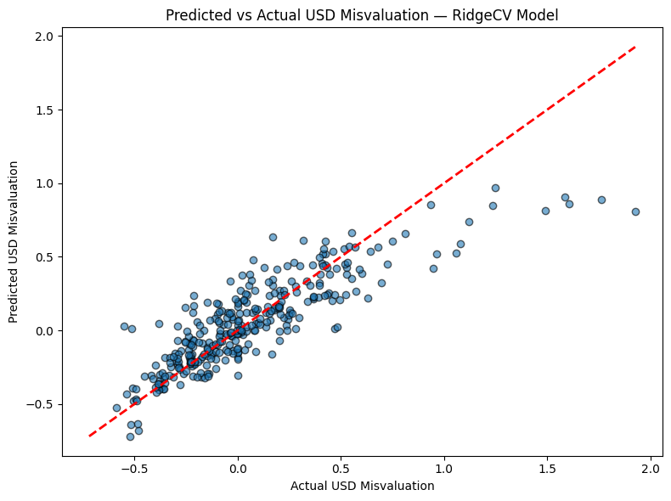

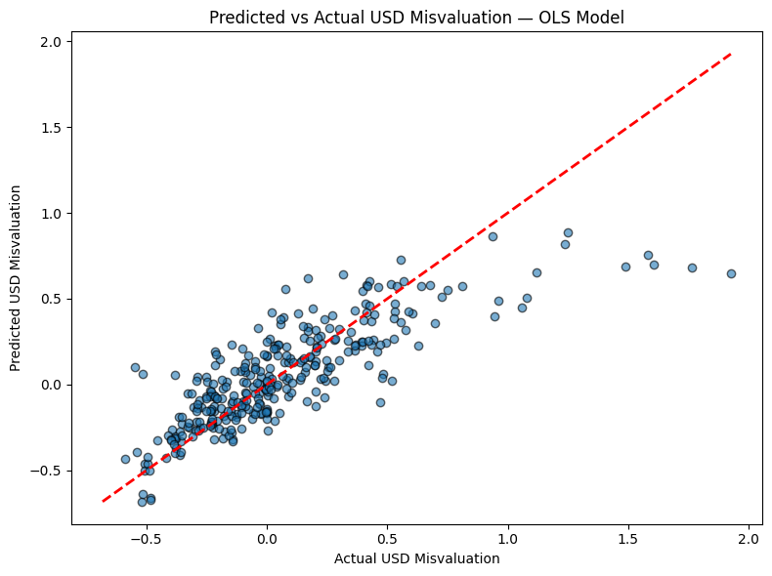

*Figure 4. Predicted versus actual values of the USD misvaluation index. The diagonal reference line represents perfect prediction. Points clustered closely along this line indicate that the RidgeCV model captures the majority of variance in the normalized index, with limited dispersion. Deviations from the line correspond to instances where country-specific or time-specific shocks introduced departures from PPP fundamentals, highlighting the limits of purely price-based explanatory variables.*

Figure 4 above presents the predicted versus actual values of the USD misvaluation index using the RidgeCV regression model. The points cluster closely along the 45-degree reference line, indicating that the model captures a substantial share of the cross-sectional and temporal variation in normalized currency misvaluation. This alignment suggests that PPP-adjusted Big Mac prices, combined with GDP per capita and country/year fixed effects, provide a strong basis for explaining valuation outcomes. The dispersion around the diagonal, however, highlights that while the model approximates parity relationships effectively, there remain systematic deviations attributable to country-specific shocks and institutional factors not captured in the predictors.

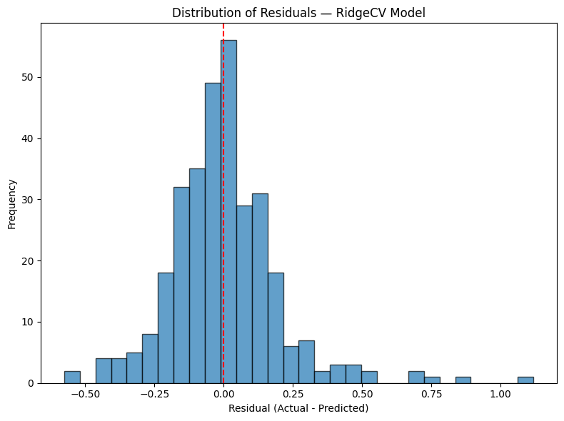

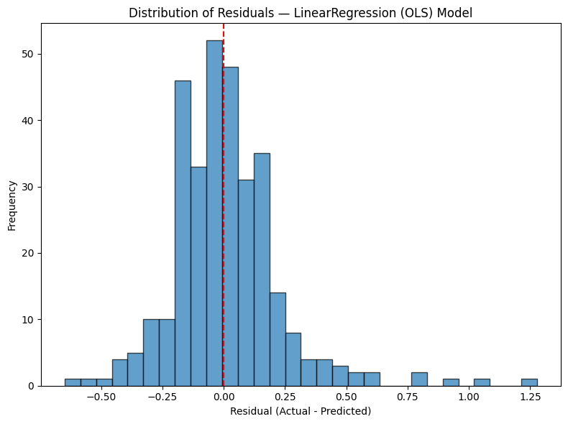

*Figures 5 & 6. Distribution of model residuals from the RidgeCV and OLS regression. Residuals are centered near zero, with a bell-shaped distribution, suggesting that the model errors are relatively symmetric and unbiased overall. The spread of residuals indicates moderate variability around the predicted values, consistent with unobserved macroeconomic factors that influence currency valuations beyond those captured by the Big Mac Index and GDP adjustments.*

To better assess model accuracy, Figure 5 displays the distribution of residuals. Residuals are centered near zero and approximately symmetric, consistent with unbiased errors. The spread of the residuals indicates moderate variability around predicted values, which reflects the presence of unobserved macroeconomic or policy drivers that extend beyond price-based fundamentals. The relatively tight clustering around zero also confirms that the RidgeCV specification meaningfully improves on the plain linear regression baseline, which produced larger and more dispersed errors. 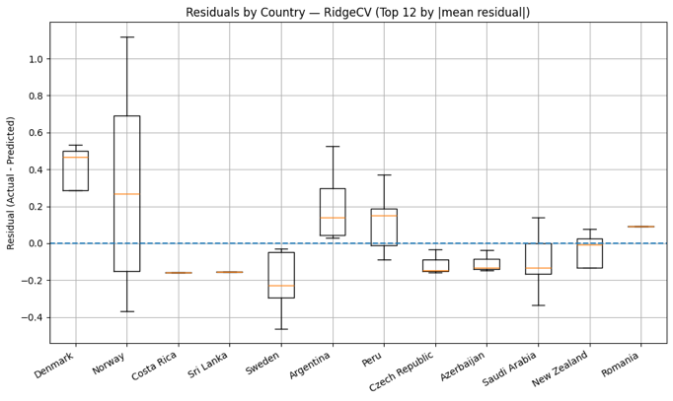

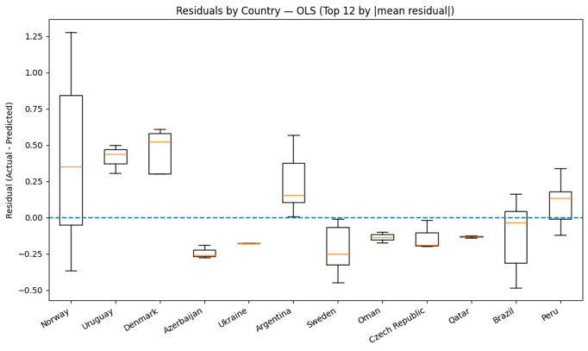

*Figure 6. Boxplots of residuals grouped by country for the twelve economies with the largest average model misfit. Positive residuals indicate systematic underprediction of currency misvaluation, while negative residuals indicate overprediction. The concentration of large residuals in certain countries (e.g., those experiencing inflationary pressures or non-market interventions) demonstrates that institutional and policy factors drive persistent deviations from PPP, which linear models alone cannot fully capture.*

Residual patterns are further explored in Figure 6, which groups prediction errors by country for the twelve economies with the largest average misfit. Several countries exhibit systematic underprediction or overprediction of misvaluation, suggesting structural biases in how the model interprets Big Mac pricing relative to actual exchange rate behavior. Economies with histories of inflationary volatility, exchange-rate interventions, or non-market policy distortions are disproportionately represented among those with large residuals. These findings reinforce the idea that PPP-based measures, while informative, cannot fully account for political, institutional, or crisis-driven deviations in currency markets.

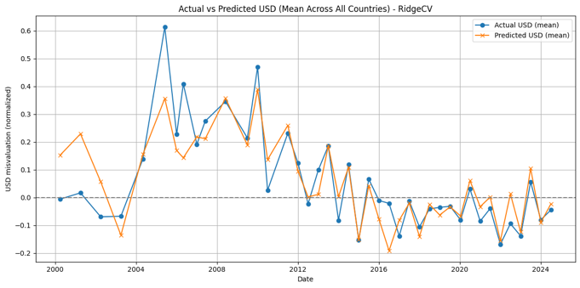

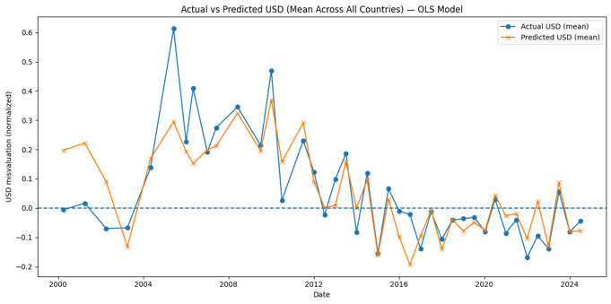

*Figure 7. Average residuals plotted across time periods, with a rolling mean overlay for the top five countries by absolute misfit. The temporal pattern shows that residuals are generally stable, but widen significantly during episodes of financial crisis or macroeconomic disruption. This suggests that while the model captures structural parity relationships, its accuracy diminishes when external shocks dominate currency movements.*

Finally, Figure 7 plots residuals over time, both in aggregate and for the five countries with the highest average misfit. The results show that model performance is relatively stable during periods of economic normalcy but deteriorates during episodes of financial crisis or macroeconomic disruption. For example, widening residuals are evident in years corresponding to global downturns or local currency crises, underscoring the sensitivity of PPP-based models to exogenous shocks. This temporal analysis emphasizes that while the Big Mac Index provides a useful framework for benchmarking relative currency valuations, it is less effective in periods dominated by crisis dynamics rather than market fundamentals.

**10.** **REFERENCES**

Bezek, I. (16 Apr 2024). *What Is Purchasing Power Parity?* Seeking Alpha. [What Is Purchasing Power Parity? Definition, Meaning & Examples | Seeking Alpha](https://seekingalpha.com/article/4683875-purchasing-power-parity?source=acquisition_campaign_bing&campaign_id=676718844&internal_promotion=true&utm_source=bing&utm_medium=cpc&utm_campaign=676718844&utm_term=1156688138500370%5edat-2324092704454783:loc-4084%5eb%5e%5e%5e%5eo&hsa_grp=1156688138500370&hsa_ad=&hsa_src=o&hsa_tgt=dat-2324092704454783:loc-4084&hsa_kw=https%3A%2F%2Fseekingalpha.com&hsa_mt=b&hsa_net=bing&hsa_ver=3&msclkid=cc3b1de836b71a085fbd7569497a7bc2&utm_content=Seeking_alpha_all)

Dabbura, I. (17 September 2018). K-means Clustering: Algorithm, Applications, Evaluation Methods, and Drawbacks. Towards Data Science. [K-means Clustering: Algorithm, Applications, Evaluation Methods, and Drawbacks | Towards Data Science](https://towardsdatascience.com/k-means-clustering-algorithm-applications-evaluation-methods-and-drawbacks-aa03e644b48a/)

Dataset (Kaggle):  
Justine231. (2024). *Big Mac Index (2024)* [Data set]. Kaggle. <https://www.kaggle.com/datasets/justine231/big-mac-index-2024>

Nobanee, H., Vo, D. T. H., Trinh, H. H., & Ullah, S. (2025)**.** The Big Mac Index: A comprehensive bibliometric and systematic review. *Research in Globalization, 10*(3), 100269. [The Big Mac Index: A comprehensive bibliometric and systematic review - ScienceDirect](https://www.sciencedirect.com/science/article/pii/S2590051X25000024#s0025)

Original source (The Economist):  
The Economist. (2024). *The Big Mac Index*. https://www.economist.com/big-mac-index

Taylor, A. M., & Taylor, M. P. (2004). The purchasing power parity debate. *Journal of Economic Perspectives, 18*(4), 135–158. [The Purchasing Power Parity Debate - American Economic Association](https://www.aeaweb.org/articles?id=10.1257/0895330042632744)